Picture
Iron Man

English:
Character description: How creatively can we describe different robots?

Newspaper Reports: To write a newspaper report about different mysterious events.

Haiku Poems: To write a poem related The Iron Man.

Texts used: The Iron Man and Newspaper articles.
Key Vocabulary:
attract
repel
magnetic
magnet
force
robot
materials
poles
push/pull
United Kingdom
regions
counties
Human and physical features

Maths:
Place value
- Count from 0 in multiples of 4, 8, 50 and
100; find 10 or 100 more or less than a given number.
- Recognise the place value of each digit in a three-digit number (hundreds, tens, ones).
- Compare and order numbers up to 1000.
- Identify, represent and estimate numbers using different representations.
- Read and write numbers up to 1000 in numerals and in words.
- Solve number problems and practical.
Addition
- Add with up to three digits, using a formal written method of columnar addition.
- Solve problems, including missing number problems, using number facts, place value, and more complex addition and subtraction.
Fractions
- To explore the meaning of a tenth.
- To make a whole.
- To count in tenths.
Shape
- To recognise angles as a property of shape or a description of a turn
- To compare angles.
Multiplication and division
- To multiply and divide by 3.
- To multiply 3 single digit numbers.
- To scale objects.
Science:
Investigating forces and magnets
- Recognise push and pull forces.
- Compare how things move on different surfaces and understand that friction slows them down.
- Understand that magnetic forces can act at a distance.
- Describe magnets as having two poles and predict whether two magnets will attract or repel each other.
- Test the strength of different magnets.
- Identify some materials that are magnetic and some that are not.

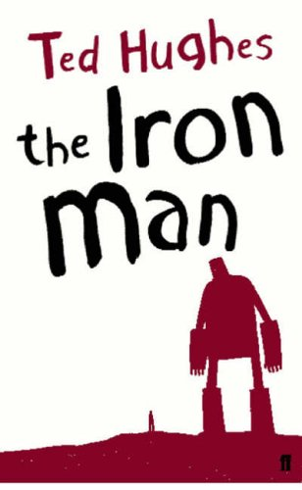

Key questions for this area of learning:
How do magnets work?
Which objects are magnetic?
What do I know about the United Kingdom?
Independent project:
Design and create a compass.
These websites could help you:
- https://www.nps.gov/articles/compass.htm
- https://sciencewithkids.com/Experiments/Physics-experiments/how-to-make-compass.html

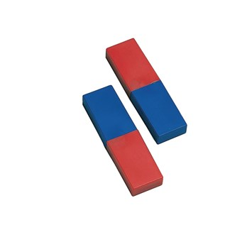

RSHE:
- My healthy self: How can I take care of my mind and body?
- Examining the connection between the mind and body by recognising and describing a wide range of emotions and feelings.
- Identifying habits that support healthy sleep
- Consider the impact of bullying on wellbeing and learn how and where to access support when needed.
PE:
Swimming
- Learn how to swim competently, confidently and proficiently over a distance of at least 25 metres
- Use a range of strokes effectively [for example, front crawl, backstroke and breaststroke]

French
Shapes
- Listen attentively to spoken language and show understanding by joining in and responding
- Explore the patterns and sounds of language through songs and rhymes and link the spelling, sound and meaning of words
- Develop accurate pronunciation and intonation so that others understand when they are reading aloud or using familiar words and phrases.

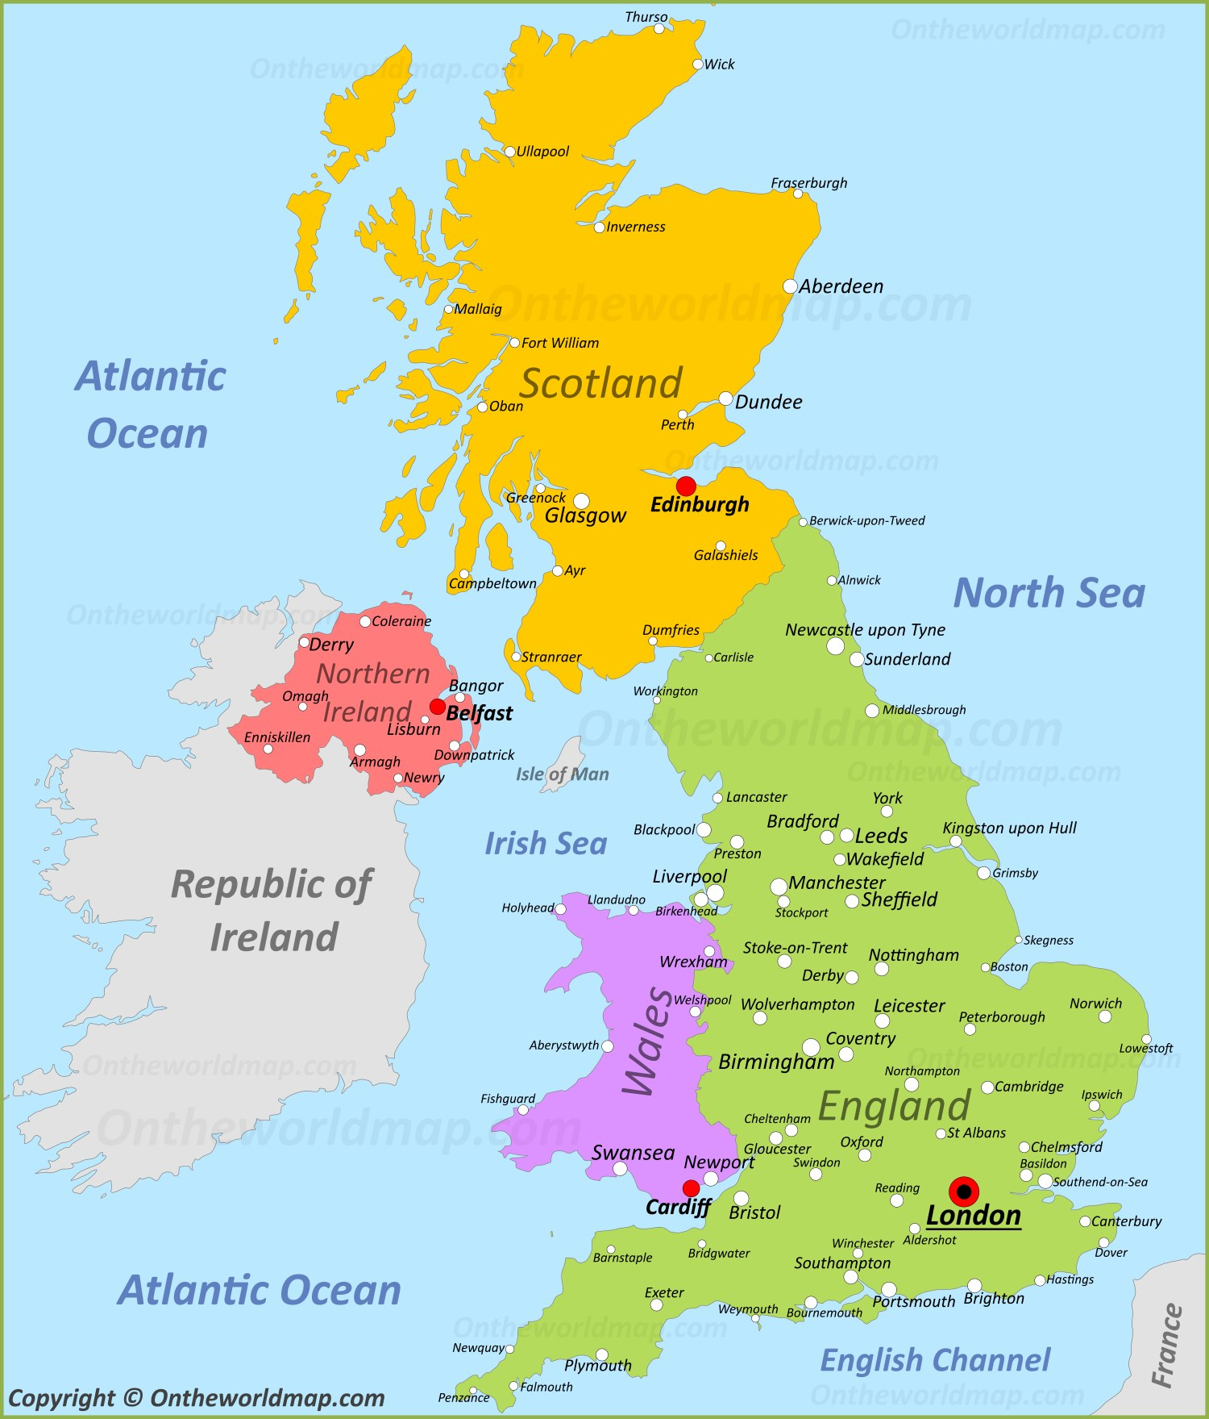
Art and Design/Design Technology:
- Explore existing games which use a magnet.
- Design, create, improve and evaluate a board game which incorporates magnets.
- Start to explore complimentary colours (colours opposite each other on the colour wheel, e.g. red and green).

Geography:
The United Kingdom
- Name and locate key cities, regions and counties in the UK.
- Name and locate key human and physical characteristics in the UK. This will include hills, mountains, coasts and rivers.
- Look at how the UK has changed overtime.
- Use maps, globes and atlases.
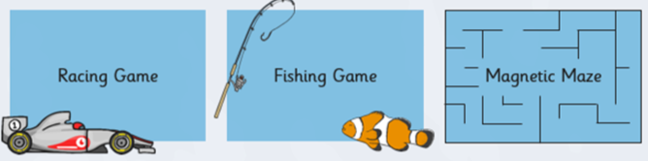
Computing:
- Explain how digital devices function
- Identify input and output devices.
- Recognise how digital devices can change the way that we work.
- Explain how a computer network can be used to share information.
- Explore how digital devices can be connected.
- Recognise the physical components of a network.

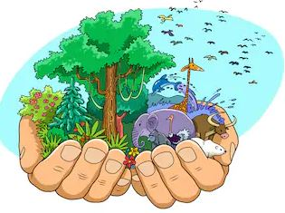

Religious Education:
Christianity
- Discuss a range of ideas about some ‘big questions’, e.g. what do Christians believe about God?
- Consider challenges that a Christian or Christian community faces.
- Describe spiritual ways of celebrating Christian festivals.
- Reflect on why some Christians value Christian festivals more than others.
- Describe and understand links between Bible stories of creation and Christian beliefs about God as the creator.

