 Science
Intent
At Muskham Primary School, it is our intention to provide a high quality Science education that equips children with the foundations they need to recognise the importance of Science in every aspect of daily life. Through delivery of a high-quality Science curriculum, pupils will acquire both the knowledge and skills required, whilst encouraging a lifelong curiosity and interest in the sciences.

Our curriculum will enable children to work collaboratively to become enquiry- based learners through researching, investigating and evaluating. Children will be encouraged to understand how Science can be used to explain what is happening, predict how things will behave, and analyse causes. It will provide opportunities for the critical evaluation of evidence and rational explanation of scientific phenomena; in addition, it enables children to apply their mathematical knowledge to their scientific enquiries: collecting, presenting and analysing data. Children will be immersed in key scientific vocabulary, which supports the acquisition of scientific knowledge and understanding.

As children progress through the year groups, they develop their skills when working scientifically, as well as their scientific knowledge. We aim to develop greater independence when planning and carrying out fair and comparative tests to answer various scientific questions.

The Science curriculum offered at Muskham Primary School is ambitious for all learners; it ensures that disadvantaged, those with special educational needs and disabilities are given the support to make good progress. For those children with high levels of SEND, a bespoke and ambitious curriculum is tailored to meet their needs.

Implementation
Teaching and Learning:
Our Science Curriculum provides full coverage of the 2014 National Curriculum, following the programmes of study for each year group. Lessons are planned using PLAN matrices as a reference for key learning, common misconceptions and vocabulary. We ensure that the ‘Working Scientifically Skills’ are embedded into every lesson to enable pupils to apply these confidently. New vocabulary is introduced through direct teaching; this is continually developed throughout school, in line with the topics.

Our curriculum is progressive: it builds upon the learning of previous years, which are identified in our Explore, Extend and Engage activities. This framework is used to generate excitement and stimulate discussion about a new topic. Explore, Engage, and Extend is a set of practical activities to support teachers in assessment for children in KS2. It enables teachers to identify misconceptions, find out what the children would like to know, and make explicit links between what the children already know and what is new. Previous learning and vocabulary will be recapped and referred to, ensuring pupils are secure with the intended curriculum content.

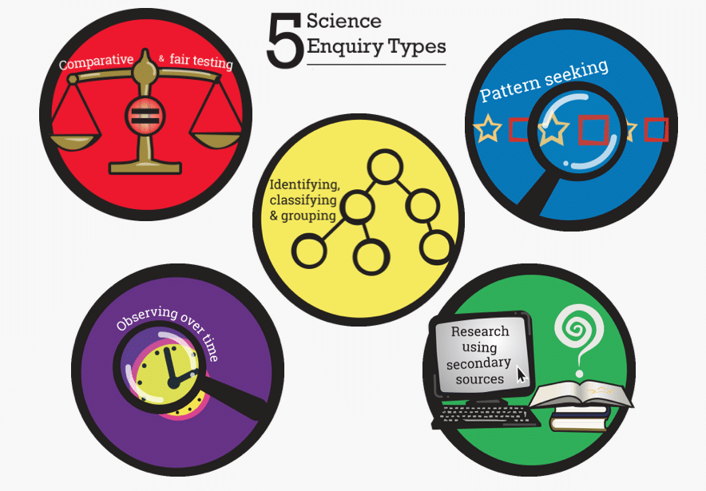
The progression of skills is developed with increasing depth and challenge as children move through year groups. They complete investigations and hands-on activities while gaining scientific knowledge. When planning a lesson, teachers consider the appropriate scientific skills in the enquiry type. These are outlined in our progression document and the focus of skill is made explicit in the lesson’s learning objective.

Where possible links are made across the curriculum: using reading skills to research topics; using mathematical skills to carry out and interpret information; using computing skills to present data and carry out research.

Through enrichment days, such as ‘science day’, we promote the profile of Science and allow time for the children to freely explore scientific topics.

Assessment:
Both formative and summative assessments are used tool for assessing the impact of Science at Muskham Primary School. Formative assessment allows for misconceptions and gaps to be addressed immediately rather than building on insecure scientific foundations. At the end of each unit of work, summative assessments are carried out. The results of which inform the planning of subsequent learning.

Monitoring and Evaluation:
- Lesson observations are undertaken to identify any CPD requirements for staff.
- Book scrutinies are carried out to monitor subject coverage and to share best practice with staff.
- Planning audits ensure coverage of progressive curriculum.
- Pupil voice is sought through interviews and surveys.

Impact
In Science, progress is measured through a child’s ability to know more, remember more and explain more. Attainment and progress measured across the school, before and after teaching units of work, shows the success of our Science curriculum. In Year 6, our teacher assessments are above the national average with 80% of children reaching the expected standard (2023 data).

Our children, who feel confident in their science knowledge and enquiry skills, are excited about science. This is evident during lessons and through pupil interviews; children show that they are actively curious to learn more and see the relevance of what they learn in the world around them.

